|  |
| --- |
|  |
| 新概念 3 册 |
| Lesson1 |

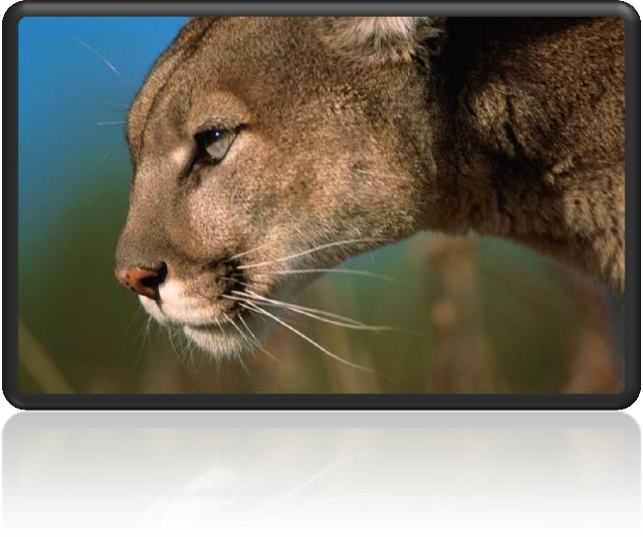**Lesson 1 A puma at large**

## 词汇

**spot [spɒt]** v. 看出，发现

发音相似 stop lot hot boss dog

* a big red spot
* a spot on one’s reputation
* A leopard won’t change its spots.

词组: spot of sth. 有点怎么样(英式)

* a spot of bother
* You seem to be having a spot of bother with your car, can I help?

词组: a scenic spot 旅游景点

* A great many of scenic spots are being spoilt by the ill-behaved tourists. The Middle East is a **hot spot.** **热点**

词组: on the spot 现场

* Four days after setting out, while the Titanic was sailing across the icy waters of the North. Atlantic, a huge iceberg was suddenly spotted by a look-out.
* Ten minutes after calling 911, a police car arrived on the spot.

**Spot 表发现**

* Dr. Marcy and Dr. Butler also spotted the first “family” of three planets. Chick Webb spotted her in an amateur competition when she was sixteen.
* Four days after setting out, while the Titanic was sailing across the icy waters of the North Atlantic, a huge iceberg was suddenly spotted by a look-out.
* He had spotted a tiny bottle at the bottom of my case and he pounced on it with delight.

**表“发现”同义词**

see / find / observe

**recognize sb. as … 认出来某人是谁**

In the torchlight, he caught sight of a figure whom he immediately recognized as Bill Wilkins, our local grocer.

identify

ID card ➔ identity card

UFO ➔ unidentified flying object

evidence ['evɪdəns]

n. 证据 (不可数)a piece of evidence

**同根词:**

**evident**

**self-evident**

All truth passes through three stages. First, it is ridiculed. Second, it is violently opposed. Third, it is accepted as being self-evident.

— Arthur Schopenhauer

Declaration of Independence

We hold these truths to be self-evident, that all men are created equal, that they are endowed by the Creator with certain unalienable rights, that among these are life, liberty, and the pursuit of happiness.

― Thomas Jefferson

(hold 书面语中做“认为”)

court 法庭

go to court 打官司

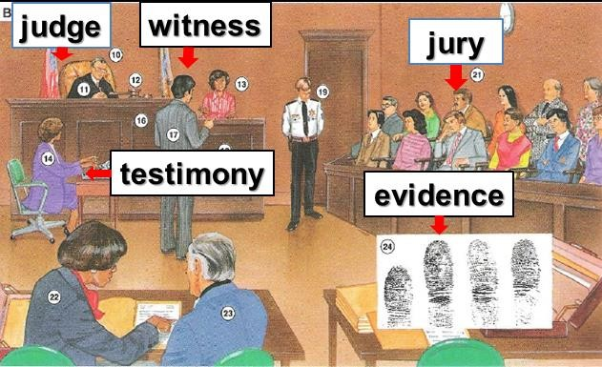settle sth. out of court 私了

**accuse** sb. of (doing) sth. 因为某事或做某事控告某人

I accused him of stealing my sheep.

**charge** sb. with (doing) sth. 指控

I charged him with stealing my sheep.

**witness** 目击者,证人

**jury** n. [法] 陪审团；评判委员会

**testimony** n. [法] 证词，证言；证据

accumulate [ə'kju:mjəleɪt]

v. 积累，积聚

accumulate knowledge / possessions

I accumulated a large vocabulary.

**amass** ***vt.*** 积聚，积累

amass a fortune

People tend to amass possessions.

**pile up** 越积越多

Meanwhile, the traffic piled up behind.

**collect** collect stamps

**gather** gather crops hoard

**hoard** Shenzhen real estate developers hoard large amounts of land.

oblige [ə'blaɪdʒ]

**v. 使……感到必须**

**obligation**

**be / feel obliged to do** 觉得不得不做

辞职信

Dear Mr. Wang,

Thank you very much for having offered me such a golden opportunity to work as an editor for Designs & Fashions, a best-selling magazine renowned for its extraordinary quality and taste. I was thrilled by the news and have tried my utmost, but after two months’ work I feel obliged to resign, which is truly a tough decision for me.

**be / feel compelled to do** (compelled表迫于外界压力)

President Nixon felt compelled to resign.

**be / feel impelled to do** 觉得不得不做 (处于良心,道义)

He felt impelled to point out that they were making a dangerous mistake.

human being ['hju:mən 'bi:ɪŋ]

n. 人类

**human being man**

**mankind humankind**

**human race humanity**

a crime against humanity

**alien being** 外星人

**intelligent being** 聪明的生物

To be, or not to be: that is the question.— Hamlet

I think therefore I am. — René Descartes

corner ['kɔ:nə(r)]

v. 使走投无路，使陷入困境

Don’t corner me! 不要逼我

A cornered beast will do something desperate. 狗急跳墙

**on / in / at / around the corner**

My birthday is just **around the corner**. 表示某个日期快到了

convince [kən'vɪns] **v. 使……信服**

**convince sb. of sth.** 使某人相信某事

* He failed to convince the jury of his innocence.

**cure sb. of sth.** 治好了某人的某个

* The doctor cured him of his lung cancer.

**inform sb. of sth.** 通知某人某事

* My ex-wife informed me of her marriage.

**remind sb. of sth.** 使某人你记起某事

* You remind me of one of my classmates.

**rob sb. of sth.** 抢某人某事

* The robber robbed me of my wallet.

**deprive sb. of sth.** 剥夺某人某事

* Some criminals were deprived of political rights.

**assure sb. of sth.** 使某人对某事放心

* The dealer assured me of its quality.

somehow ['sʌmhaʊ] adv. 不知怎么搞地， 不知什么原因

And I couldn’t remember what it felt like when I could not walk down the street without holding her hand.

I mean she was the same woman I fell in love with, she hadn’t changed. But somehow everything’s different. We've lost something along the way.

**somewhat** 有一些,有一点怎么

He was somewhat hungry.

He was somewhat embarrassed.

**somewhere** 某处,在某个地方

I’ve lost my wallet somewhere around here.

disturb [dɪ'stɜ:b]

**v. 打扰，令人不安 (不着急的场合)**

**短语: Do not disturb.** 请勿打扰

I hope I'm not disturbing you.

Sorry to disturb you, but …

Sorry to disturb you, but I really need your help.

## 课文

**at large**

a puma which was at large

语法: 关系代词作主语,其后紧接be动词,作主语的关系词和be动词可同时省略

a prisoner / suspect at large

The disease is still at large.

**cat-like**

bear-like animals

lady-like behavior

child-like simplicity

an angel-like girl

crystal-like eyes

flu-like symptoms

As is shown in the picture, there is a **cobweb-like** structure with separate compartments packed in it.

Foxes and farmers have never got on well. These small **dog-like** animals have long been accused of killing farm animals. *(CET-4)*

**Pumas are large, cat-like animals found in America.**

**短语:be found in …** 产于

Many plant and animal species are found only in the rainforests. Vitamin C is found in citrus fruit.

造句: 大熊猫 (giant panda) 是一种大型的，类似于熊的动物，产于中国四川省。

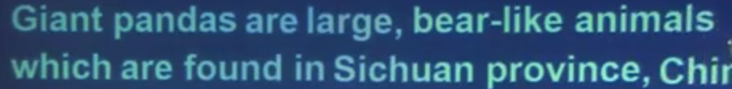

He came into the classroom.

**无灵主语 / 物称主语** (inanimate subject)

However, a new type of humor, which stems largely from the US, has recently come into fashion. The dealer told him that it had just come in, but that he could not be bothered to open it.

例:

**I thought of a good idea.**

A good idea came into my mind.

A good idea flashed into my mind.

**He went to the town on business.**

Business took him to the town.

A warm and sunny Sunday found my whole family going for an outing at the beach.

同位语从句和定语从句的区别

1、从定义上看：同位语从句解释前面名词的具体内容；而定语从句仅起到后置定语的作用， 常译为“……的”。

2、从形式上看：同位语从句中的“that”仅起到连接符号的作用，不充当语法成分；而定语从句中的“that”是关系代词，在从句中充当主语、宾语或表语。

The proposal that John should be dismissed is unacceptable. 同位语从句

The proposal that John put forward is unacceptable. 定语从句

同位语并列:

We hold **these truths** to be self-evident, that all men are created equal, that they are endowed by the Creator with certain unalienable rights, that among these are life, liberty, and the pursuit of happiness.

― Thomas Jefferson

**词组: had been seen / found / observed …** 被发现

**方位介词: in / on / to the south of …** 只有to可省略

in : 在内部 Shanghai is in the south of China.

on: 在外部 Vietnam is on the south of China.

to: 中间有间隔 Indonesia is to the south of China.

to 省略: 100 kilometers south of Xi'an

**take … seriously**

**take … lightly**

… they were taken lightly.

课文: When reports came into London Zoo that a wild puma had been spotted forty-five miles south of London, they were not taken seriously.

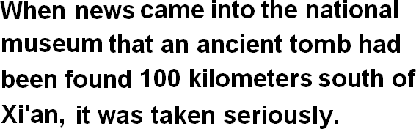**造句：**当消息 (news) 传到了国家博物馆 (the national museum)，说是在西安以南 100 公里处发现了一座古墓 (an ancient tomb) 的时候，这则消息受到了重视。

**However 转折**

**Investigate 调查**

**investigate** the market **investigate** the case

the FBI: the Federal Bureau of Investigation

**原因状语从句引导词**

**because** (回答why)

**since**

**as**

**for** 逗号for引起原因状语从句

**in that**

**now (that)**  不能跟过去式

Now that a tunnel has been built through the mountains, the Pass is less dangerous, but each year, the dogs are still sent out into the snow whenever a traveller is in difficulty.

**非谓语动词**

**give descriptions**

… descriptions which were given by people … **make descriptions**

… descriptions made by people …

The hunt for the puma began in a small village where a woman picking blackberries saw a large cat only five yards away from her.

John had a very good day and put his wallet containing ₤3,000 into the microwave oven for safekeeping.

For hundreds of years, St. Bernard dogs have saved the lives of travellers crossing the dangerous Pass.

novels written by Lu Xun

movies directed by Zhang Yimou

The man leaning against the wall named George is my brother.

**claim to do …** 声称

**claim to have done …** 动词不定式的完成时

So far, no organization **has claimed to be responsible** for the accident.

Everyone went to the funeral, for the 'ghost' was none other than Eric Cox, a third brother who was supposed **to have died** as a young man.

When I was a boy, my grandfather told me how a German taxi driver, Franz Bussman, found a brother who was thought **to have been** killed twenty years before.

**发音: 重音后移**

extraordinarily

primarily

absolutely

necessarily

temporarily

**… were extraordinarily similar**

替换: were particularly alike

had a lot in common

had considerable commonalities

—well, I saw the ad on the back of the bus stop today. And, uh… though it was not exactly like looking in the mirror, you can't deny that there is a **certain commonality** in our **visages**.

—I guess we do look **a little bit alike**

**复述:**

However, *as the evidence began to accumulate*, experts from the Zoo felt obliged to investigate, for the descriptions *given by people who claimed to have seen the puma* were extraordinarily similar.

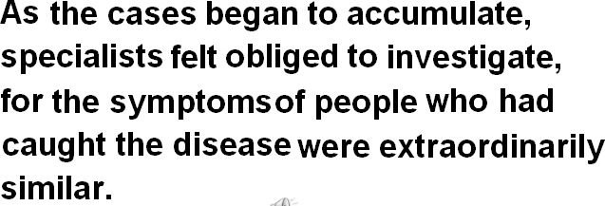**造句:** 随着病例 (case) 开始慢慢增多, 医学专家们 (specialist) 觉得必须要调查了,因为得了这种病的人的症状 (symptom) 特别地相似。

**介词:**

hunt for …

I’m hunting **for** a job now.

The hunt **for** a job will begin tomorrow.

the winter **in** America

the entrance **to** the parking lot

a witness **to** the accident

a longing **for** love

the reason **for** the disaster

**发音**

woman villager 村姑

[w] [v]

**“ 仅仅 “**

only

just …

merely …

no more than …

**confirm 证实说**

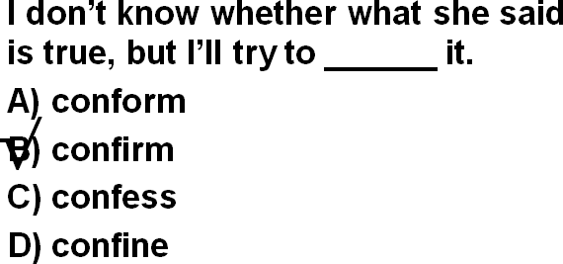President Hu Jintao confirmed that he would visit the United States next month.

**prove 系动词**

**prove (to be) + adj. / n.** 被证明是……

His injury proved (to be) fatal.

The operation proved (to be) a success.

**turn out to be + adj. / n.** 原来是……

When the archaeologists reconstructed the fragments, they were amazed to find that the goddess turned out to be a very modern-looking woman.

**疑问词 + ever (whenever, wherever, whoever, whichever, whatever ...) 有两个含义：**

表示“无论……”引导让步状语从句。

= no matter + 疑问词

No matter where it went, …

No matter where you live, you would find it difficult not to laugh at, say, Charlie Chaplin's early films.

表示 “到底……” 用于疑问句中。

'Whatever are you doing up here Bill?' asked the vicar in surprise. Wherever did you go yesterday?

Whenever am I going to see you again?

When will you ever learn?

A. These things take time to learn.

B. Will you study anymore?

C. Why do you keep on making the same mistakes?

D. It will be a good learning experience for you.

Answer: (C) Why do you keep on making the same mistakes?

Wherever it went, it left *behind it* a trail of dead deer and small animals like rabbits.

**a trail of** 一连串的

Wherever he went, he left a trail of … behind him.

Wherever he went, he left a trail of unpaid bills behind him.

Wherever he went, he left a trail of broken hearts behind him.

造句：人们对下岗工人的生活状况越来越关注了。

1.People have paid more and more attention to the condition of the laid-off workers. 2.Increasing attention has been paid to the condition of the laid-off workers.

fur a fur coat

feather fur and feather 飞禽走兽

fin, fur and feather 各种各样的动物

The **crown** should not yield to the **cross**.

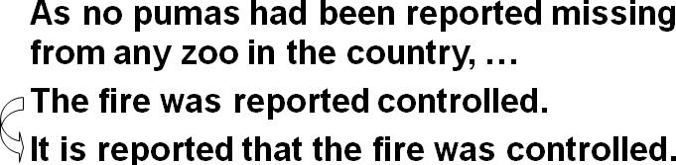 **主语不足语**

**complain of / about sth.** 抱怨说

claim 声称说

confirm 证实说

put it 措辞说

stated that 声明说

Then I added with a smile, ‘It’s a strange mixture I make myself.’…,

as one of them put it ‘ate like kings’.

The writer stated that Rastus was in safe hands …

on a business / honeymoon trip

on a journey / voyage / expedition / tour …

… on a five-nation tour. 路上和在途中用介词 on

convince sb. of sth.

**be convinced that … that**引导的从句不在介词后

in that … 因为

except / but that …

out 这里是副词

After telling several of his friends about the theft, Dimitri **found out** **that** his neighbour, Aleko, had suddenly acquired a new lamb.

He ***was*** a WOMAN! 重读was

**must have done** 对过去肯定的推测

You must have been ill yesterday. You looked so pale.

**must do** 肯定是

She knew that it must be the baker.

**may / might have done** 可能是

**can not / could not have done** 不可能是

You can’t have been ill yesterday. I saw you going shopping with your wife.

The girl asked to see a timetable, feeling sure that her father could not have made such a mistake.

责备语气，

**should / ought to have done** 该做的没做

**should not / ought not to have done** 不该做的做了

You should have finished your work yesterday.

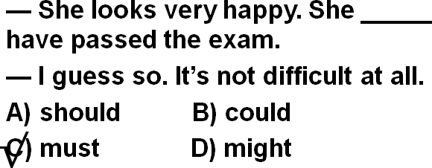 I shouldn’t have shouted at you yesterday.

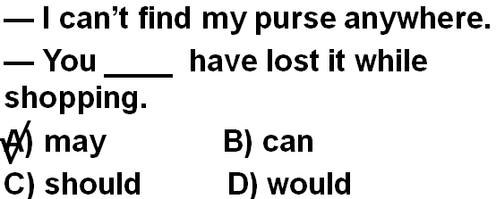

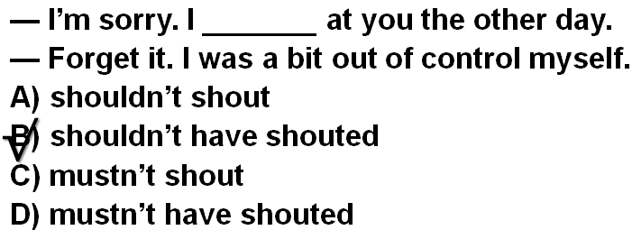

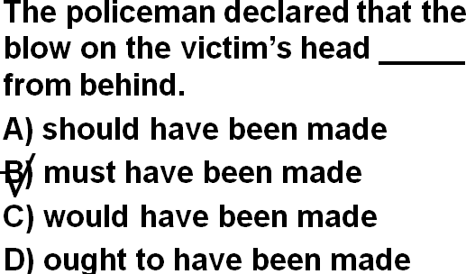

**in the possession of sb. / in one’s possession**

**in possession of sth.**

The book is in my possession .

I’m in possession of the book.

**in the charge of sb. / in one’s charge** 负责

**in charge of …**

The bookstore is in my charge .

I’m in charge of the bookstore.

**manage to do** 设法完成了某事

Our vicar is always raising money for one cause or another, but he has never managed to get enough money to have the church clock repaired.

**fail to do** 没能完成某事

When the journalist again failed to reply, the editor reluctantly published the article as it had originally been written.

**主语从句**

It is disturbing to think that a dangerous wild animal is still at large in the quiet countryside.

It is … to think that … 一想到某事就令人….

It is worrying to think that …

It is exciting to think that …

It is comforting to think that… I

t is amusing to think that …

It is irritating to think that …

## 课后

* Summary writing

In not more than 80 words describe how experts came to the conclusion that the animal seen by many people really was a puma. Do not include anything that is not in the passage.

Answer these questions in note form to get your points:

1 What sort of reports were received by London Zoo?

2 Were the reports similar in nature or not?

3 Who saw it first?

4 Did it stay in one place, or did it move from place to place?

5 What did it leave behind it?

6 Were paw prints and puma fur found as well or not?

7 What was heard at night?

8 Was the animal seen up a tree or not?

9 Were experts now sure that the animal really was a puma or not?

* Vocabulary

Give another word or phrase to replace the following words as they are used in the passage: spotted (1.2); accumulate (1.4); obliged to (1.5); claimed (1.6); extraordinarily similar (1 .6); immediately (1.8); convinced (1.15).

* Composition

Describe the occasion when the woman picking blackberries saw the puma. Expand the following into a paragraph of about 150 words.

Mrs. Stone had spent the whole morning ... It was nearly lunch time, so she decided ... She was just ... when she heard a noise in ... Then she saw an animal which ... She knew it was not a cat because ... The animal suddenly ... and she thought it was going to ... She dropped her basket and ... Hearing the sound, the animal ... after which, Mrs. Stone ... and ran all the way home. She told her neighbours that ... but they did not believe her. She also telephoned the police but they...

(86 words)

* Letter writing

On a full page, show the exact position of each of the following:

The address and date; the beginning of the letter; the Introduction; the signature; the postscript. Supply all necessary full stops and commas.

* Exercise

Underline all the joining words in the passage. Note carefully make compound or complex statements.

**A** Complete these sentences by adding a suitable word to the end of each one:

1 What are you looking ________?

2 Where is your mother going _______?

3 Whom has the letter been sent ______?

4 This is the house I was born _______?

5 What does your decision depend ________?

**B** Write these sentences again changing the position of the words in italics. Where possible, omit the words whom or which.

1 He is the man about whom we have heard so much.

2 The shelf on which you put those books has collapsed.

3 From whom did you receive a letter?

4 This is the road by which we came.

5 Where is the pencil with which you were playing?

* Multiple choice questions

Choose the correct answers to the following questions.

Comprehension

## 课后答案